

THE ARAGON COLLECTION
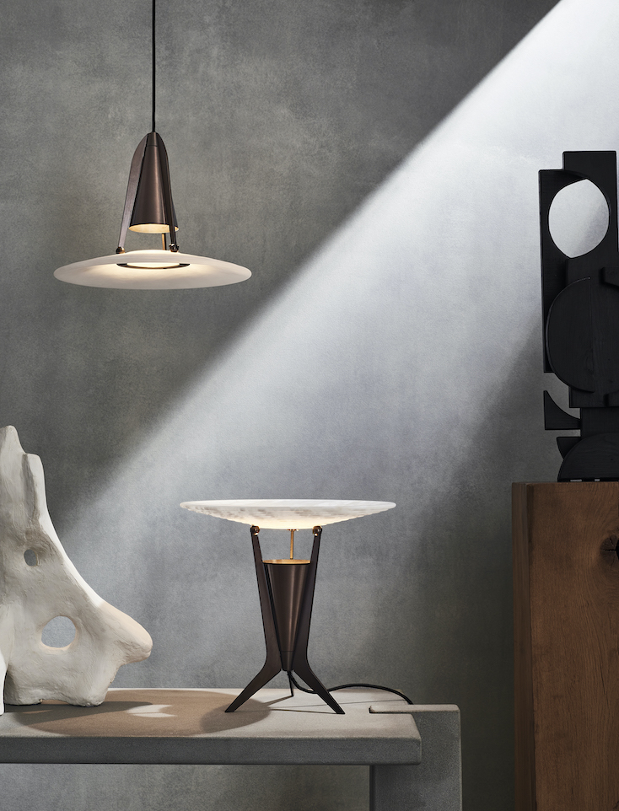

A striking mix of pearly, white alabaster and bronzed solid brass, Aragon is the latest lighting collection from British design brand J. Adams & Co. - now available exclusively online.
Exploring the translucent and reflective properties of the sculptural stone within the J. Adams & Co. design process for the very first time, the Aragon lighting collection further explores the theme of texture and light, in material and illumination.
Sourced from the Aragon region of Spain which provides its name, the conical alabaster shade features gentle stepped contours. When illuminated, the alabaster takes on new beauty, revealing the opalescent depth of the revered material. Designed to both reflect and diffuse light, creating an optimum spread of ambient illumination whilst concealing the light source and any associated glare, Aragon provides a soft, functional light.
Combining J. Adams & Co.'s industrial language with a refined architectural and Art Deco edge, the elegant and slim machined brass body with splayed fins is finished in a moody and lustrous, burnished bronze. Stylistic and expressive.
The Aragon collection includes a pendant light, table lamp and floor lamp and is also available in an antique brass finish.

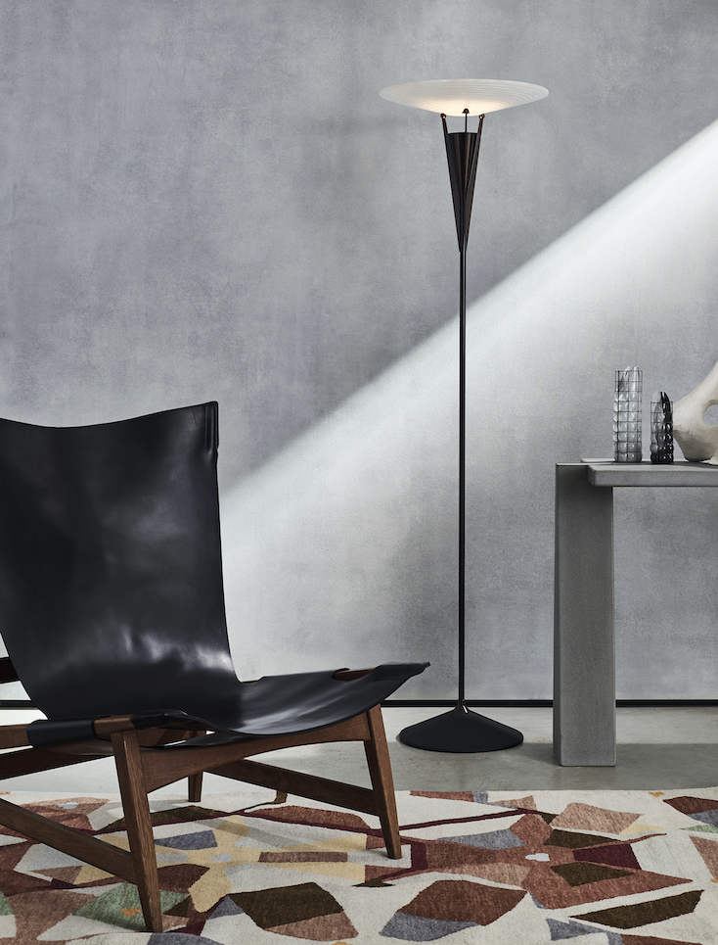

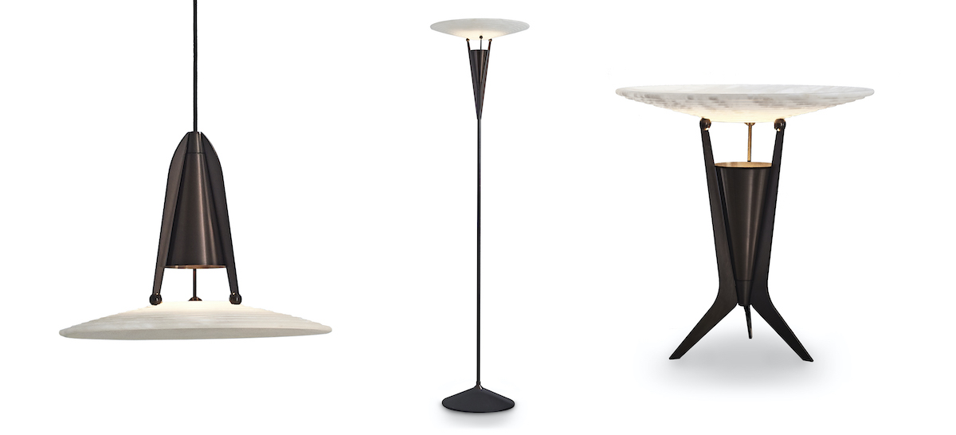

For high resolution imagery, quotes and product loans, please contact Kelly Teasdale at Teasdale PR: kelly@teasdalepr.com | +44 (0) 7734 689511

J.Adams & Co | www.jadamsandco.com | +44 (0)207 164 6418 | @jadamsandco

Notes to Editors
Founded in 2016 and led by Creative Director Will Earl, J. Adams & Co. showcase craftsmanship, innovative engineering and authentic design made in Britain. Combining an industrial aesthetic with modern elements, J. Adams & Co. redefine classic styles in contemporary form to create their timeless collections. Materiality and manufacturing expertise are at the heart of the brand, with each product made by hand in the companies UK Birmingham factory using only the highest quality materials.

